Hailey Robe

Griffin Rocco

Emerson Zamensky

ENVS1001

Final Report

**Summary**

A steward of the environment could not successfully function in the consumerist society we know without making some immediate changes to the operations of the largest producers of pollution. Amazon, the largest e-commerce retailer in the world (Forbes 2019), accounted for about 50 percent of all online sales in 2018 (Figure 1), and is projected to keep growing through 2021 (Statista 2020). With this impressive business growth comes *a lot* of cardboard. In fact, paper and cardboard accounts for the most municipal solid waste (MSW) of any category in total MSW production in the US, according to Figure 2. Instead of displacing the responsibility of recycling this cardboard on its customers and further fueling the company’s demand for more cardboard, we think Amazon should be a true leader of E-commerce and become a model sustainable business for the rest of the world by providing an Amazon recycling service. Our project entails the implementation of recycling facilities across the country. To calculate the number of plants required, data on Amazon's shipping statistics are needed. The reality of this utopian plan is also determined by its cost and benefit. The estimated cost of our plan is based on the cost of running the required 63 recycling plants. In addition to the recycling service provided by Amazon, we also posit the company could reduce its demand for packaging if it incentivizes customers to find Amazon-owned stores to buy certain items that are currently over-commodified. We think that while this may be counterintuitive to a normal business model, honoring environmental justice is ultimately the most revered action.

Sustainable development and business success can totally exist in the same realm. Case in point, Interface, a carbon neutral carpet tile company, provided inspiration for our ideas. The late founder, Ray Anderson, realized he could only be proud of his company if it followed an ambitious path void of a harmful footprint. We realize the need for action should not wait for economic growth and that Amazon can follow this path.

**Scope of the Problem**

As seen in Figure 3, total MSW production has steadily increased over time, and in conjunction with figures 1 and 2, this can be linked to Amazon’s huge contribution of cardboard demand. There are several problems with Amazon’s use of packaging, including the consumption of packages, amount of packaging used, the available opportunities for recycling, and the need for fast delivery. First, Amazon causes a huge amount of consumption by adding online options to in-store shopping. It would be easiest to decrease the amount of packaging used by decreasing the consumption of Amazon products. Second, Amazon’s high sales result in an equally high amount of packaging, and they have attempted to address this problem by recycling through several different programs. Amazon has partnered with the Closed Loop Fund, which builds infrastructure to help with manufacturing for large-scale retail operations, and they donate food or other items to decrease waste and promote reusing and recycling (“Circular Economy”).

In addition, the Amazon Second Chance program provides information on the different types of packaging that Amazon uses and how to recycle these items (“Amazon Second Chance”). Most types of packaging, including cardboard boxes, paper envelopes, and paper padded mailers can be recycled with standard “curbside” recycling services (“Amazon Second Chance”). However, some types of packaging require customers to bring the packaging to participating stores in their area to recycle them; these types of packaging include the Prime Now insulated pouches and the bubble-lined plastic bags (“Amazon Second Chance”). Since this requires customers to go out of their way to recycle these items, Amazon could implement better recycling opportunities to remove responsibility from the customer.

Finally, fast delivery may reduce sustainability because it causes inefficient deliveries. This has caused Amazon to place less packages on each truck, separate orders into different packages, and visit the same area more than once per day. This increases the amount of packaging used and the emissions from delivery trucks. Furthermore, since there is a market for on-demand deliveries, an increasing amount of companies are offering this service, including Postmates, UberRush, Jet Delivery, and Instacart (Richtel 2016). This is inefficient because more delivery trucks now visit the same area (Richtel 2016).

**Available Data**

The available data for the problem of Amazon packaging includes information about current recycling facilities in the United States as well as how many tons of recyclables are processed through these facilities. Additional information includes the amount of Amazon packages mailed per year, and how much the packaging itself weighs. The sources for this information include several news articles and analyses, which are referenced throughout the back of the envelope calculation. Overall, it would have been helpful to find sources on packaging weight from Amazon itself, which would have helped to make our calculation more accurate. Easily accessible, transparent information from Amazon about the number of packages sent, emissions, and data from their recycling programs also would have been helpful. However, the information we found allowed us to complete our back of the envelope calculation and come to our solution.

**Proposed Solution**

The size and popularity of Amazon is on an upward trend. In order for them to become a model sustainable business for the rest of the world, they must take this waste dilemma into their own hands. Amazon attempted to reduce waste in the past by mitigating cardboard consumption per order in 2008, yet every year since then their production of waste has increased. Based on this fact and modern day complications that make approaching this problem from a mitigation standpoint difficult, our solution will instead capitalize off of this increasing amount of waste. Our proposed solution requires Amazon to use its own private recycling service to ensure its recyclables are not wasted by customers. This will reduce Amazon’s carbon footprint and improve business. To do this, they will place Amazon recycling centers in various locations around the United States. Our calculation determined that Amazon will require 63 recycling centers throughout the U.S to handle its 3,506,250 tons of packaging that is used each year. This will cost approximately $18,900,000.

Although it is a fair amount of money, it has been found that companies that implement various green policies such as a recycling program can actually both save the company money and make the company money. They can recycle the waste to meet demand and sell some of their returned waste (Clean River, Recycling Solutions 2020). If they choose to sell a portion of it, the market value of waste recycled services has been increasing since 2017 and is projected to increase to $376 billion U.S dollars by the year 2024 (Wang 2019). The price of cardboard alone has also been increasing due to more and more people around the world purchasing things online (Berg Mill Supply). The environmental benefits of recycling will also save the company money on things such as water and energy, as discussed in the following paragraph. Hence, our solution will take advantage of the increased popularity of Amazon everywhere and the rising price of recycled materials.

The environmental benefits correlate to economic ones too. Cardboard is made from tree pulp similar to paper (Matter of Trust). If cardboard is recycled, it decreases the need to cut down new trees to retrieve new pulp. Recycling one ton of cardboard is the equivalent of saving about 17 trees. This pulping process also requires a fair amount of water and energy. One ton of recycled cardboard can save up to 7,000 gallons of water and 5,000 kilowatts (Matter of Trust). Most of the time, energy reduction leads to a decrease in overall fossil fuel use as well, which reduces CO2 emissions (Mourad et. al 2008). Through our proposed solution, Amazon will be recycling over 3 million tons of cardboard per year, saving an estimated 51 million trees, 21 billion gallons of water and 15 billion kilowatts of energy.

An issue that may arise during this process is the economic hit of the initial cost of the recycling stations. If Amazon is projected to have a major fall out because of the predicted $18 million cost, we could spread out the time they are all put in place. A quarter of the desired 63 stations could start up at select locations initially, then Amazon can simply wait until they can earn a certain amount of money back to implement the next quarter.

Amazon is expanding in size and pervasiveness every year. It is important that they know that with their increasing success comes increasing environmental accountability. Our solution of an Amazon specific recycling program has the potential to reduce over 3 million tons of waste, save trees, water and energy, and generate profit.

**Figures and Diagrams**

**Figure 1**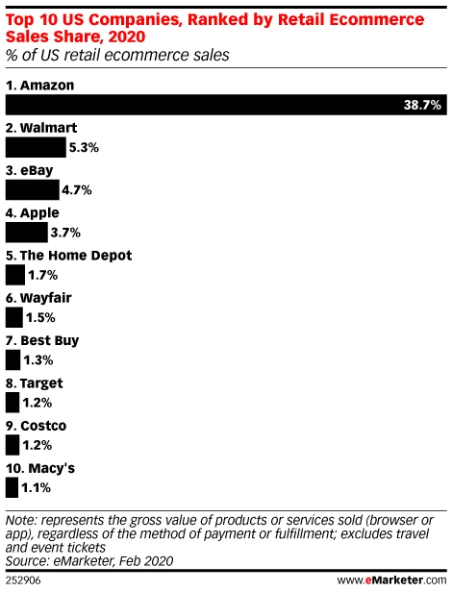

(Source: eMarketer.com)

Figure 1 shows how Amazon disproportionately makes up US e-commerce sales. In fact, its share of total sales is greater than the next 9 largest e-commerce sales producers. Subsequently, Amazon also disproportionately generates MSW. We think that a company with this magnitude of sales must consider the magnitude of the hidden costs and negative externalities that come with it.

**Figure 2**

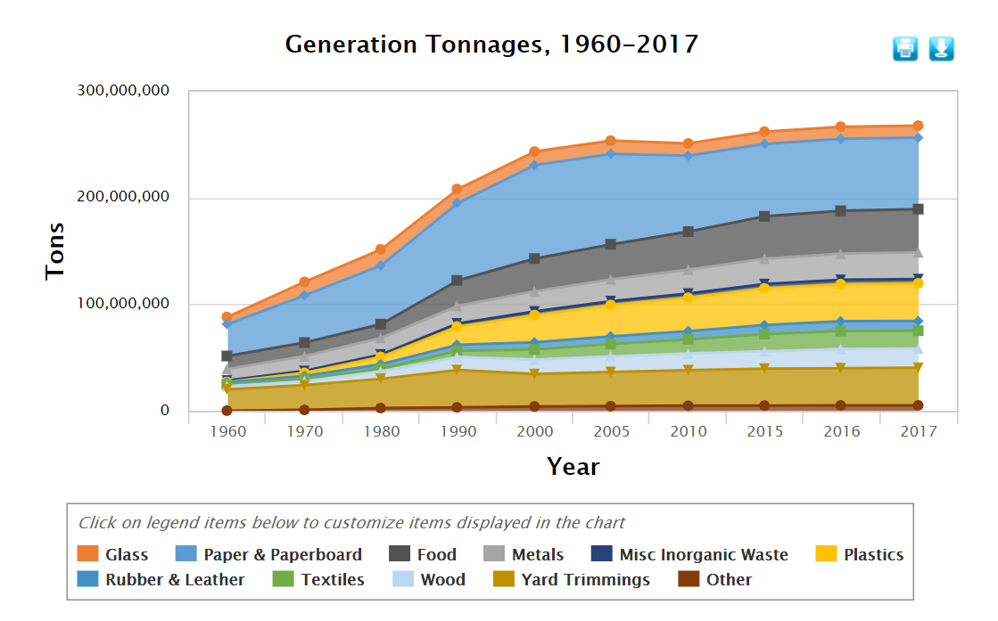(Source: US Environmental Protection Agency)

Figure 2 portrays the increasing demand for cardboard, proportional to the booming e-commerce industry. Paper and cardboard accounted for 25% of all MSW generated in 2017, or 87.74 million tons!

**Figure 3**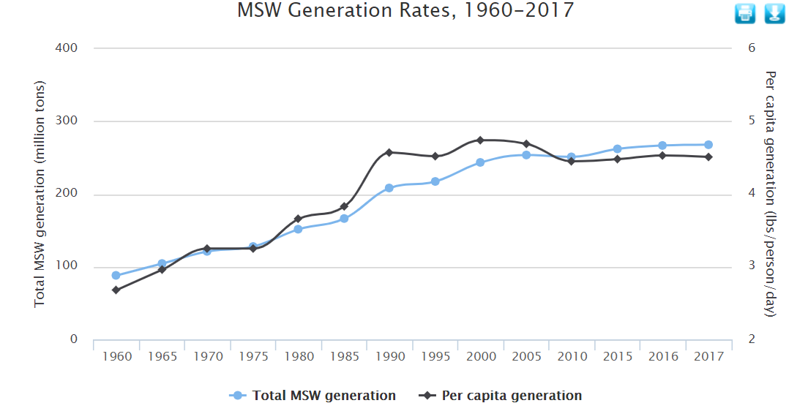

(Source: US Environmental Protection Agency)

Figure 3 shows the steady increase in total and per capita MSW generation from 1960 to 2017. We anticipate that as e-commerce grows, the gap between per capita MSW generation and total MSW generation will also increase. Per capita MSW consumption may be on a decline or hitting a plateau, however, the total waste generation may continue to grow, reflecting the continuous extraction and manipulation of resources from industrial MSW generators. A steady decrease in both total and per capita MSW can be achieved through environmental action from the corporations producing the most waste.

**References Cited**

Amazon Second Chance. (n.d.). Retrieved from <https://www.amazon.com/amsc>

Angelovska, N. (2019, May 20). Top 5 Online Retailers: 'Electronics And Media' Is The Star Of E-commerce Worldwide. Retrieved from <https://www.forbes.com/sites/ninaangelovska/2019/05/20/top-5-online-retailers-electronics-and-media-is-the-star-of-e-commerce-worldwide/#1b9f67a71cd9>

Cardboard Recycling, Environmental Impact. (n. d.). *Matter of Trust.org.* Retrieved from <https://matteroftrust.org/cardboard-recycling-environmental-impact/>

Circular Economy. (n.d.). Retrieved from

<https://sustainability.aboutamazon.com/packaging-and-products/closing-the-loop-on-waste>

Clement, J. (2019, August 9). U.S. Amazon market share in e-commerce and retail 2021. Retrieved from <https://www.statista.com/statistics/788109/amazon-retail-market-share-usa/>

Mourad, A. L., Garcia, E. C., Viela, G. B., Zuben, F. V., “Environmental Effects from a

Recycling Rate Increase of Cardboard of Aseptic Packaging System for Milk Using Life Cycle

Approach.” *The International Journal of Life Cycle Assessment*, Ecomed, 1 Jan. 1970, Retrieved

from <https://link.springer.com/article/10.1065/lca2007.06.340>

National Overview: Facts and Figures on Materials, Wastes and Recycling. (2020, March 13). Retrieved from <https://www.epa.gov/facts-and-figures-about-materials-waste-and-recycling/national-overview-facts-and-figures-materials>

Recycled Cardboard Prices Reach Record-Breaking Highs. (n. d.). *Berg Mill Supply.* Retrieved from

<https://bergmill.com/2017/06/20/recycled-cardboard-prices-reach-record-breaking-highs/>

Richtel, M. (2016, February 16). E-Commerce: Convenience Built on a Mountain of Cardboard. Retrieved from <https://www.nytimes.com/2016/02/16/science/recycling-cardboard-online-shopping-environment.html>

Wang, T., Aug 9, 2019. Size of the Waste Recycling Services Market Worldwide in 2017 and 2024. *Statista.* Retrieved from <https://www.statista.com/statistics/239662/size-of-the-global-recycling-market/>

Why is Recycling Important for a Business? 5 Surprising Benefits. (n. d.) *Clean River Recycling Solutions*. Retrieved from <https://cleanriver.com/blog-why-recycling-important-for-business/>

**Appendix A: Back of the Envelope Calculation**

Our Goals

For our plan, we will require Amazon to build recycling plants designed to recycle their packaging.

For our calculation, we will address:

* How many recycling plants will be necessary to efficiently handle the amount of packaging Amazon produces?
* What will be the cost of these recycling plants?

Calculation

“The United States currently has 633 materials recycling facilities, which can clean, sort and bale a total of 100,000 tons of recyclables per day” (O'neill 2018)

* If 633 recycling plants handle 100,000 tons of recyclables per day, that is approximately 158 tons of recyclables handled per plant per day
  + 100,000 tons/ 633 recycling plants = 158 tons of recyclables per plant per day
* Assuming a recycling plant operates 350 days per year (assuming they are closed a total of 15 days for holidays, maintenance, or other reasons), this means each recycling center can process 55,300 tons of recyclables per year.
  + 350 days operating * 158 tons of recyclables per day = 55,300 tons of recyclables per year

Amazon itself ships approximately 2.5 billion packages per year, FedEx ships approximately 3 billion Amazon packages per year, and UPS delivers 4.7 billion Amazon packages per year for a total of 10.2 billion packages per year, assuming that these are the only companies handling Amazon packages (Cheng 2019).

According to an online seller, one 12”x12”x8” box weighs approximately 11 ounces (Lane 2018).

* Assuming that this is a standard, common box size, we will use this weight to calculate the total weight of Amazon packaging per year.
  + 10.2 billion packages per year * 11 ounces each = 112,200,000,000 ounces of Amazon packaging per year
  + 112,200,000,000 ounces to tons:
    - 1 ton = 32,000 ounces
    - (112,200,000,000 ounces) * (1 ton/ 32,000 ounces) = 3,506,250 tons of Amazon packaging is produced per year.

According to our earlier calculation, one recycling center can process 55,300 tons of recyclables per year. To process 3,506,250 tons of packaging, Amazon would need 63 recycling plants.

* 3,506,250/55,300 ~ 63

To find the cost of the recycling centers:

Assuming recycling centers have an estimated operating cost of $25,000 per month, based on the monthly cost of the facility, employees, equipment, and utilities, this is $300,000 per year (“The Cost of Starting a Full Force Recycling Program”).

To build and operate 63 recycling centers, this would cost Amazon approximately $18,900,000.

* $300,000 * 63 centers = $18,900,000

In Conclusion

Amazon will require 63 recycling centers throughout the United States to handle its 3,506,250 tons of packaging that is used each year. This will cost approximately $18,900,000.

References for Back of the Envelope Calculation

Cheng, A. (2019, December 12). Amazon Ships 2.5 Billion Packages A Year, With Billions More Coming, In A Major Threat To UPS And FedEx. Retrieved from https://www.forbes.com/sites/andriacheng/2019/12/12/how-serious-is-amazons-threat-to-ups-fedex-study-finds-it-could-soon-beat-them-in-us-package-delivery-volume/#687b34d468f4

Lane, R. (2018, November 28). Estimating Shipping Weight: A Primer for New Shop Owners. Retrieved from https://www.rubylane.com/blog/categories/vintage-collectibles/estimating-shipping-weight-a-primer-for-new-shop-owners/

O'neill, K. (2018, August 17). The plastic waste crisis is an opportunity for the U.S. to get serious about recycling at home. Retrieved from https://phys.org/news/2018-08-plastic-crisis-opportunity-recycling-home.html

The Cost of Starting a Full Force Recycling Program. (n.d.). Retrieved from https://www.generalkinematics.com/blog/cost-starting-full-force-recycling-program/

**Appendix B: Statement of Author Contributions**

Hailey Robe: “Scope of the Problem,” “Available Data,” and Appendix A/ BOE Calculation

Griffin Rocco: “Summary”, “Figures and Diagrams”

Emerson Zamensky: “Proposed Solution”